South Island Figure Skating Championships- Gore 19th-21st August
T-SHIRT ORDER FORM
T-Shirts cost $25 each. On both designs, the South Island image will be filled with all of the competitor’s names.
There will be a very limited amount for sale at the competition, in limited sizes, so please pre-order so that you don’t miss out! I will be placing this order on Thursday the 11th of August at 5pm to allow printing time, so please send this form back to me before then.
Ladies/Girls Design: Mens/Boys Design:
Same design as ladies except without the skater
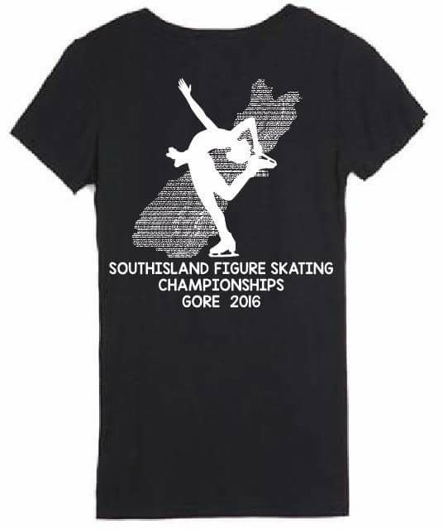Please see sizing charts on the following page
Name:_____________________________________________
Product: | Colour: | Size: | Quantity: | Cost:
Ladies V Neck T-Shirt | Black
Kids Round Neck T-Shirt | Black |  | Gender?
Mens Round Neck T-Shirt | Black
Please pay via internet banking to:
Account name- South Island Ice Skating Sub Association.
ANZ Account no: 01 0695 0033115 00
Please include skaters name and TSHIRT as a reference when making payment
T-Shirts can be collected from Registration or from the Skate Hire room during the competition.
Please return this form to Melissa Cummings on melissamorris796@yahoo.co.nz to place your order.

Men’s Sizing

Size: | XXS | XS | S | M | L | XL | 2XL | 3XL | 4XL | 5XL | 6XL
Chest:  (cm) | 87 | 92 | 97 | 102 | 107 | 112 | 117 | 122 | 127 | 132 | 137
Neck: (cm) | 34 | 36 | 38 | 40 | 42 | 44 | 46 | 48 | 50 | 52 | 54

Ladies’ Sizing:

Size: | 4 | 6 | 8 | 10 | 12 | 14 | 16 | 18 | 20 | 22 | 24
Bust:  (cm) | 76.5 | 79 | 84 | 89 | 94 | 99 | 104 | 111 | 116 | 121 | 126
Waist: (cm) | 58.5 | 61 | 66 | 71 | 76 | 81 | 86 | 93 | 98 | 103 | 108
Hip:  (cm) | 86.5 | 89 | 94 | 99 | 104 | 109 | 114 | 121 | 126 | 131 | 136

Children’s Sizing:
Size:
Chest:
(cm)
Neck: (cm)
Size: | 2 | 4 | 6 | 8 | 10 | 12 | 14 | 16
Chest:  (cm) | 58 | 60 | 64 | 68 | 72 | 76 | 80 | 86
Waist: (cm) | 54 | 56 | 58 | 60 | 64 | 68 | 72 | 76

